[Note: To complete this template, replace the bracketed text with your own content. Remove this note before you submit your outline.]

Hypothesis Testing for Regional Real Estate Company
[Your Name]
Southern New Hampshire University

Introduction
The real purpose of the analysis is to be able to confirm or nullify/reject the advertisement of the salesperson. This same report analysis will be useful in analyzing real estate information/data. In this report, my designed hypothesis on the 1001 samples home sales within the pacific region. Basing on the results found, if my null hypothesis were supported, then the advertisement of the salesperson would not receive any approval. In order to determine if either the null-hypothesis will be rejected or Accepted based on the 0.5 significance value, we will utilize the P-value

Setup
Having considered the pacific region, the populations’ real MEAN is not known. The population parameter investigated in the analysis is the, cost per square foot within the pacific region. The (H0) is the given the cost per square foot in the pacific region that is equal to or greater than $275. On the other hand, the alternative hypothesis (Ha) is the mean cost per square foot within the pacific region is less than $275. In this analysis, I will be utilizing the left-tailed test.

Data Analysis Preparations
The sample is non-symmetric, unimodal, bell shaped and right skewed. The measurement are shown below. The sample statistics of 1001 home sales are utilized to test the advert and histogram developed below.
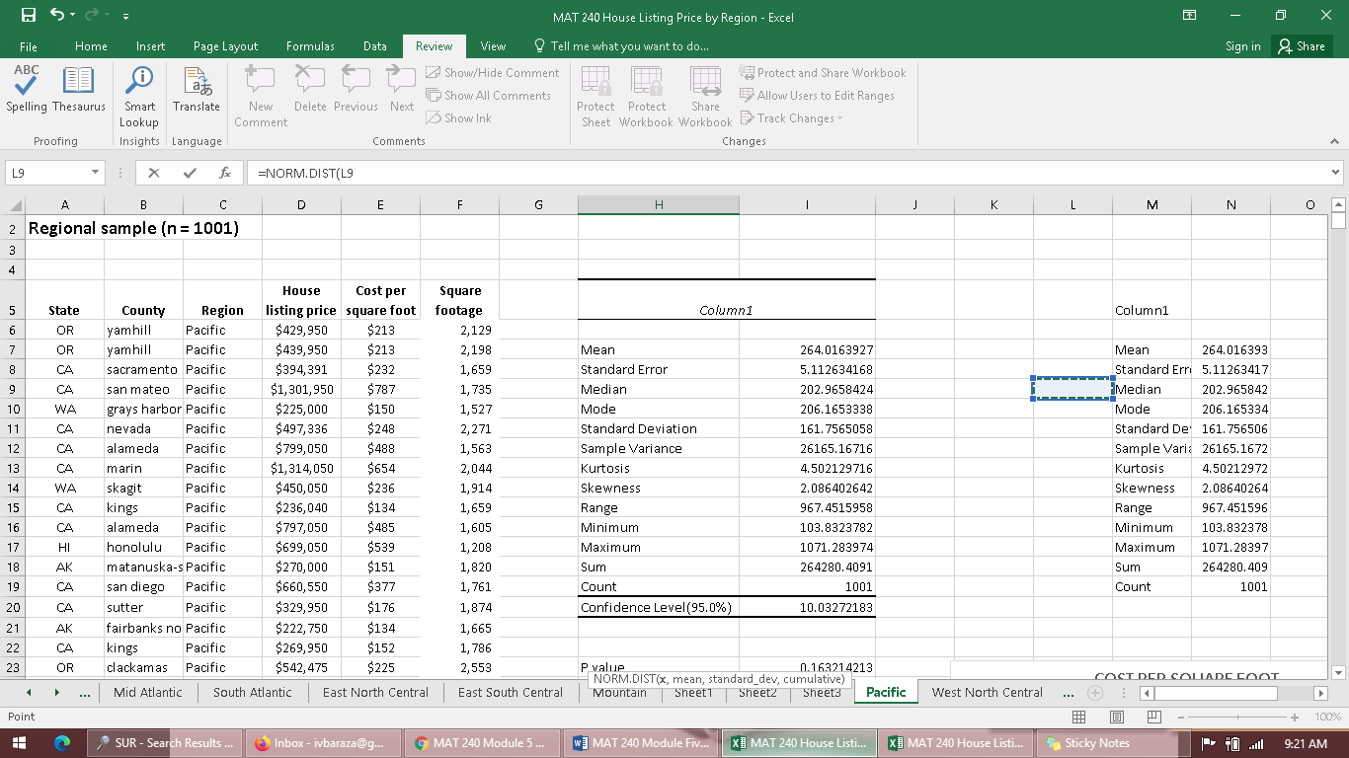

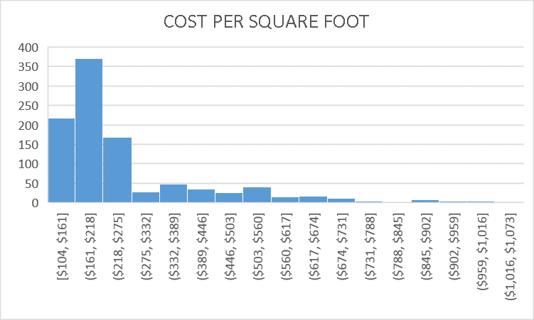
The histogram is right skewed and centered between 104 dollars and 275 dollars. Considering this, the condition to perform my left tailed test has been met already. My t-statistics is -2.215 and the level of significance remains to be 0.05. The sample statistics contains sample of about 1000 within the pacific region, I tried to include all in my t-test calculation in order to get the p-value. Considering all this, I tend to believe that conditions to perform my identity has been met because sample is from the whole population, I utilized only 50 samples from the population and finally, sample of 50 out of a sample above 1000 is less than 10% of the entire population.

Calculations
Since I used the left-tailed data, I will use =T.DIST ([test statistic], [degree of freedom], 1). Having the t-test value of -2.215. The degree of freedom being 1000, the p values is retained as 0.98651793 after calculation.

Test Decision
Based on the p-value, the level of significance will be the determinant of whether the Null hypothesis (H0) will be rejected or accepted. In our case, the p-value is P (0.045767324) and the significance level is 0.5. The value of P is lower than the significance level, thus we are able to reject the Null Hypothesis (H0) stating that, the cost per square foot is equal or greater than $275. The evidence supports the alternative Hypothesis (Ha) that suggest, the cost per square foot is less than $275 in the pacific region.

Conclusion
In the analysis, my hypothesis was tested to prove if the advertisement by the salesperson would be accepted or declined. Based on the analysis, the null hypothesis was declined and on the other hand, the alternative hypothesis was accepted. This has to mean that, in the pacific region, the mean cost per square foot has been confirmed to be less than $275 and thus disapproving the advertisement. These conclusions remain to be statistically correct since the value of P (0.045767324) does not exceed the level of significance of 0.5

